Service | GPU request / limit | CPU request | CPU limit | Memory request | Memory limit | Evidence / right-sizing rationale
dms-api | none / none | 250m | 500m | 512Mi | 1Gi | API handles lightweight FastAPI control-plane traffic and metadata operations, so a modest request is enough while leaving headroom for bursts.
dms-worker | none / none | 500m | 2 | 1Gi | 4Gi | Worker performs the heaviest jobs in the system: Kaggle downloads, CSV parsing, Parquet generation, and dataset curation, so it needs the largest CPU/memory headroom.
dms-scheduler | none / none | 100m | 250m | 256Mi | 512Mi | Scheduler only runs Celery beat and periodic maintenance triggers, so it is the lightest service.
postgres | none / none | 500m | 1 | 1Gi | 2Gi | PostgreSQL is the metadata source of truth and benefits from steady reserved memory plus moderate CPU for queries and writes.
redis | none / none | 100m | 250m | 256Mi | 512Mi | Redis is used as Celery broker/result backend and has a small in-memory footprint for this project scale.
metabase | none / none | 250m | 500m | 512Mi | 1Gi | Metabase is an operational UI for exploration and curated views, so it needs moderate memory but not worker-level compute.

api.yaml
worker.yaml
scheduler.yaml
postgres.yaml
redis.yaml
metabase.yaml

Cluster Link : https://chi.uc.chameleoncloud.org/project/instances/b29db0f0-3ada-4fd5-98d1-e2bb1728bd8e/

sh-3.2# openstack server show proj26-dms-k3s
Show that you used one Chameleon bare-metal node:
Link chameleon instance : https://chi.uc.chameleoncloud.org/project/instances/b29db0f0-3ada-4fd5-98d1-e2bb1728bd8e/
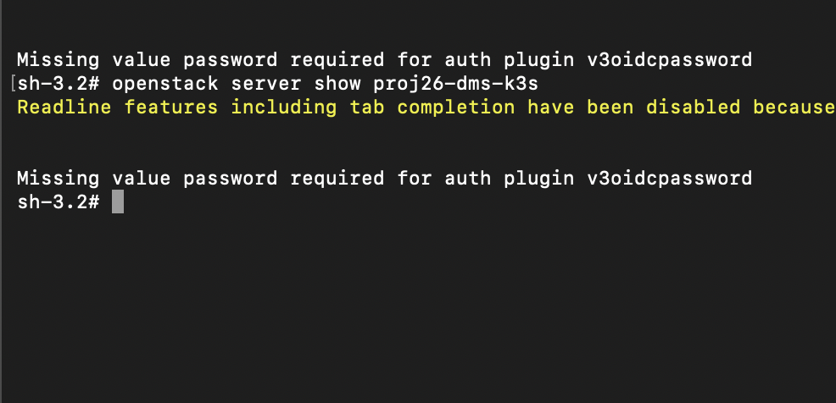

kubectl describe node

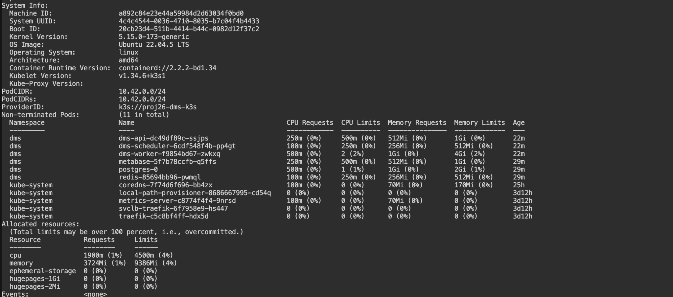

kubectl top node –

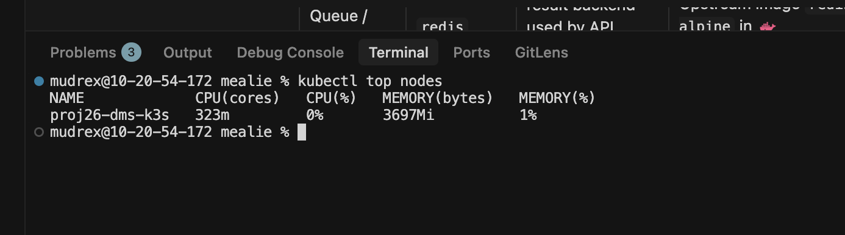

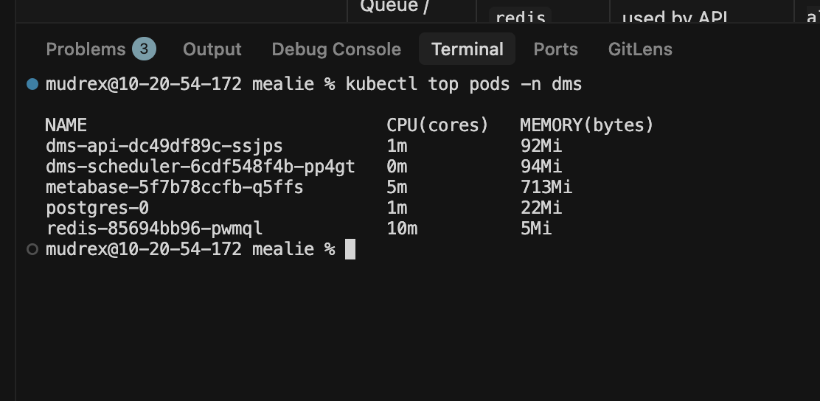

Train Infra …..

